SDLC 2026 – BSI Key Controls
Clarification and Additional Evidence Request
To: Joshua de Leon – IT Governance & PMO (Process Owner contact for the SDLC controls)
From: Edward – IT RCSA, Cycle 2
Reviewers: Mingo Cordova, Mirna Roxana
Date sent: 11/02/2026
Controls: BSI.IT.23.C1, BSI.IT.23.C13, BSI.IT.23.C17, BSI.IT.23.C25, BSI.IT.23.C4
Samples: ALCO – Security Lending (DH 3263) and Derivatives Non-Deliverable Forwards – NDF (DH 3264)
Review period: 09/01/2025 – 08/31/2026
Please respond by: ____ / ____ / 2026

Why you are receiving this
IT RCSA has finished testing the five SDLC key controls. Most of the testing passed. This document lists only the points that still need your help: one failed sample (C1) and the items where we need a confirmation or extra evidence before we can close the testing. Items that are only recommendations are listed at the end for information and do not need a reply.
How to use this document
- Each request (CR-01 to CR-13) has the same parts: what we found, the documents in question, screenshots with the exact place marked in red, what we need from you, and why it matters.
- Every document in question is in the zip, in the folder with the same request number (for example "CR-01 C1 BRD approved after Build\01 Documents"). The screenshots are in "02 Screenshots" in the same folder.
- At the end of each request there is an empty box for Joshua de Leon to write the explanation. Please put any new evidence in that request's "03 Your Response Evidence" folder and write the file names in the box.
- Dates in this document are MM/DD/YYYY. ServiceNow ticket screenshots show dates as DD/MM/YYYY.
- If another team owns the answer (for example Enterprise Architecture, CDO, Information Security or the T24 team), please forward the request and paste their answer in the box.

Summary of requests
Ref | Control | What we need (short) | Type | Priority | Affects the rating?
CR-01 | C1 Business Requirement | Business requirements for the Appian release were approved after Build started | Exception – evidence or explanation needed | High | Yes – C1 is proposed "Needs Improvement" because of this item
CR-02 | All five controls (C1, C13, C17, C25, C4) | Completeness of the population could not be confirmed | Extra evidence | High | No – but completeness of the population cannot be confirmed without it
CR-03 | All five controls | The 2026 SDLC process map is still in Draft | Validation | Medium | No
CR-04 | C13 Design of System / C17 Solution Intent | Enterprise Architecture approval was requested as a Gate 5 item, after Build started | Validation | Medium | No (today) – would be an exception if ARB review had been required
CR-05 | C13 Design of System | HIGH data risk rating – CDO data deliverables not provided | Extra evidence | Medium | No
CR-06 | C17 Solution Intent Document | Security Lending Single Design shows another Delivery Hub ID and has no dates | Validation | Low | No
CR-07 | C25 Implement & Deployment | The final implementation plan was attached after the last approval and earlier versions were deleted | Validation | Medium | No (today) – would be an exception if the plan changed materially after approval
CR-08 | C25 Implement & Deployment | Roll Back section of the Security Lending R01 Deployment Plan is empty | Validation | Low | No
CR-09 | C4 Segregated Environments | The same login (MIASANG) is used on production and non-production | Validation + extra evidence | Medium | No (today) – would be an exception if developers can change production
CR-10 | C4 Segregated Environments | Non-production environment holds client deals (possible copy of production data) | Validation + extra evidence | Medium | No (control text does not cover data masking)
CR-11 | C4 Segregated Environments | No register of exceptions (development or testing in production) was provided | Extra evidence | Medium | No
CR-12 | C4 Segregated Environments | Segregated Environments evidence was created after the review period and screenshots have no date | Validation + extra evidence | Low | No
CR-13 | C4 Segregated Environments | No evidence of separate Appian development, test and production environments | Extra evidence | Medium | No

CR-01 – Business requirements for the Appian release were approved after Build started
Control: BSI.IT.23.C1 Business Requirement
Sample: Sample 1 – ALCO Security Lending (DH 3263), Release 01 (Appian)
Current result: FAIL – exception EX-C1-01
Type of request: Exception – evidence or explanation needed | Priority: High | Affects the rating: Yes – C1 is proposed "Needs Improvement" because of this item

What we found
- The control requires the Business Sponsor to approve the business requirements before Build starts.
- Delivery Hub shows the project passed the Build gate (PTB – Gate 4) on 10/31/2025 for "ALL" releases (screenshot 1).
- The BRD for Release 01 (Appian workflow) was approved by Ted Fernandez on 02/06/2026 (screenshot 2), about three months after Build started. The BRD approvers table only shows "February, 2026" (screenshot 3).
- Your e-mail of 02/09/2026 explains that the "friends and family" business artifacts "did not mention Appian", so a new release was documented (screenshot 4).
- However, the approval request of 02/06/2026 says "Those same documents were approved during phase 1" (screenshot 2). If that phase 1 approval exists, is dated before 10/31/2025 and covers the Appian requirements, the exception can be closed.
Documents in question
Copies are in the zip folder "CR-01 C1 BRD approved after Build\01 Documents". The package location is shown in brackets.
- BSI.IT.23.C1.13 - Security Lending gate history (PTB 10-31-2025).docx – look at: screenshot 2 – row "10/31/25 PTB (4) ALL". (Build gate date; package folder: C1 Business Req/CPA/S1 Security Lending)
- BSI.IT.23.C1.04 - Security Lending R01 sponsor approval 02-06-2026.msg – look at: e-mail body – "Sent: Friday, February 6, 2026"; sentence "Those same documents were approved during phase 1". (Sponsor approval date; package folder: C1 Business Req/CPA/S1 Security Lending)
- BSI.IT.23.C1.03 - Security Lending R01 BRD.docx – look at: page 2 – "Approvers" table, Date column "February, 2026". (Approval date not complete; package folder: C1 Business Req/CPA/S1 Security Lending)
- BSI.IT.23.C1.14 - Security Lending Appian release emails 02-2026.msg – look at: e-mail from Joshua De Leon, 02/09/2026 9:57 AM – "did not mention Appian verbiage". (Reason for the new release; package folder: C1 Business Req/CPA/S1 Security Lending)
Screenshots (the exact place is marked in red)
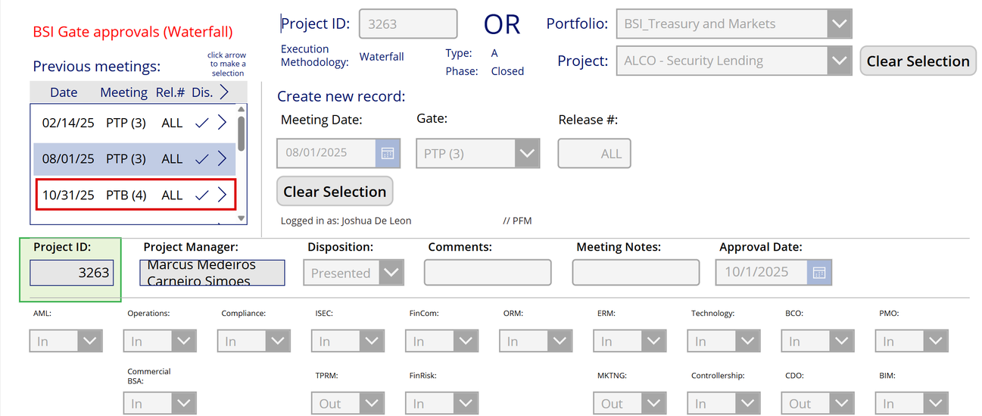
Screenshot 1 – Delivery Hub gate history, project 3263: Build gate PTB (4) on 10/31/25 for ALL releases (file BSI.IT.23.C1.13).
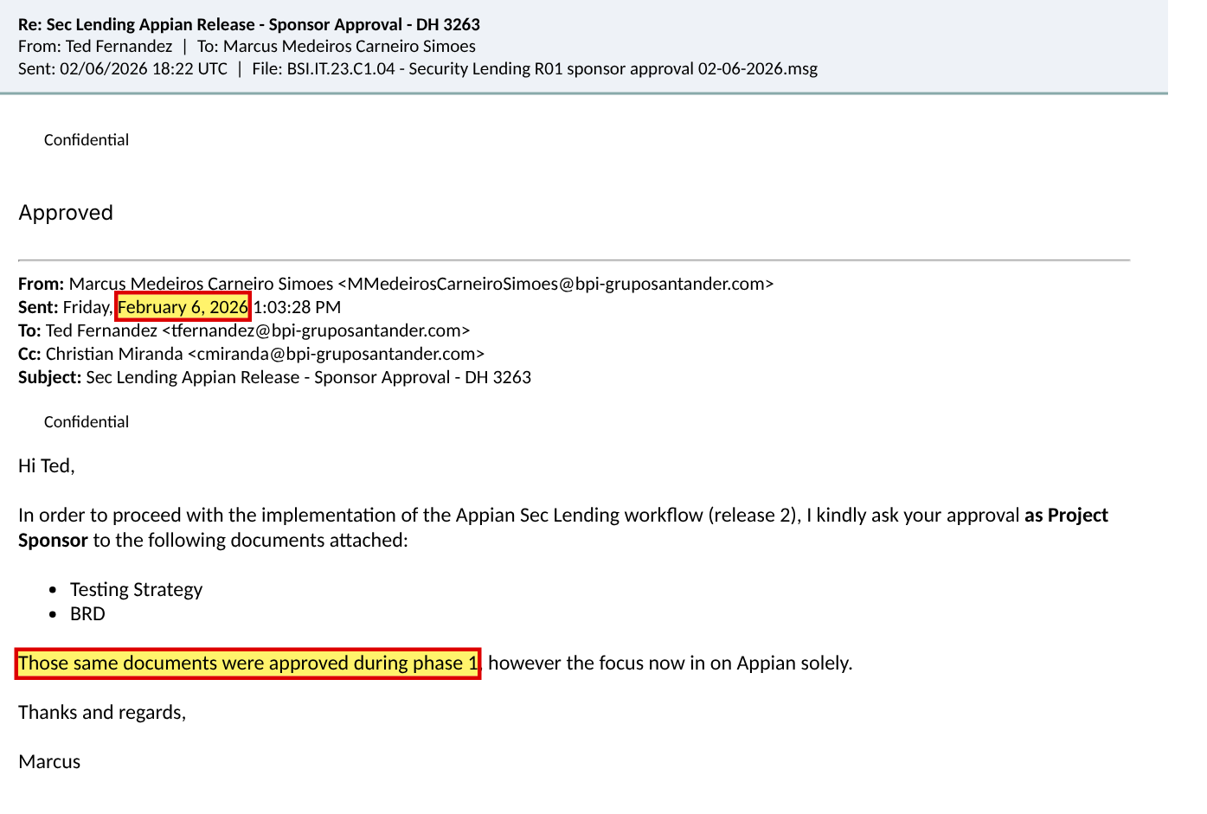
Screenshot 2 – Sponsor approval of the Appian BRD on 02/06/2026; note "Those same documents were approved during phase 1" (file BSI.IT.23.C1.04).
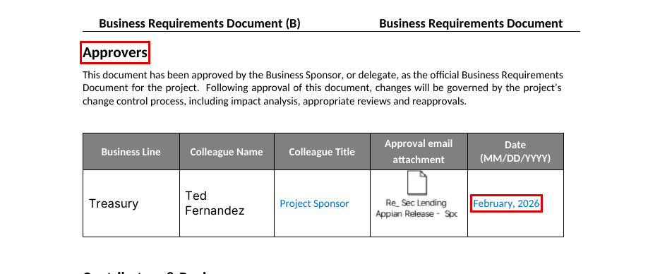
Screenshot 3 – Release 01 BRD, page 2: approval date shows only "February, 2026" (file BSI.IT.23.C1.03).
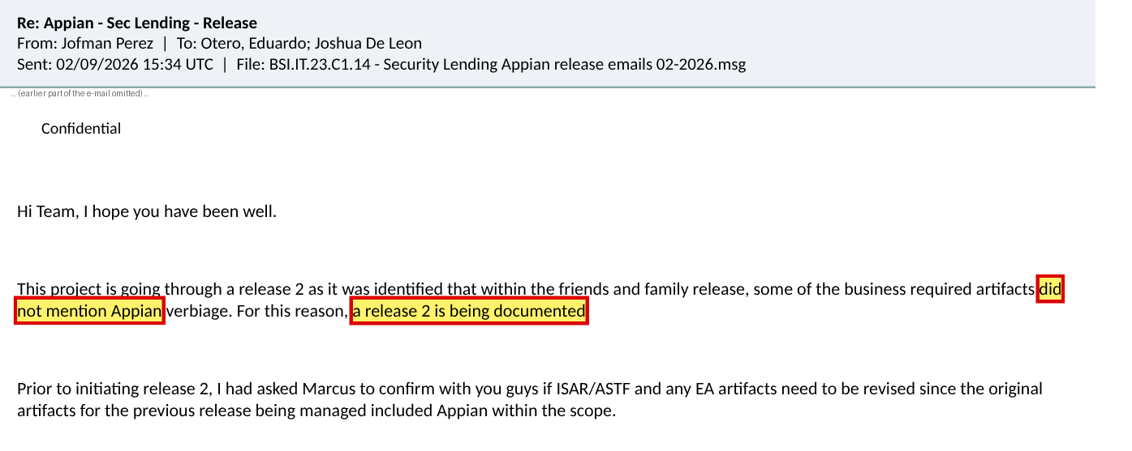
Screenshot 4 – PMO e-mail 02/09/2026: release 1 business artifacts "did not mention Appian" (file BSI.IT.23.C1.14).
What we need from you
1. The phase 1 BRD and the Business Sponsor approval e-mail (dated before 10/31/2025) that include the Appian workflow requirements – this is the evidence that would turn Sample 1 into a Pass.
2. If that approval does not exist: a short explanation of why Appian development started before its requirements were approved, and confirmation of the date Appian build actually started.
3. Confirmation of whether the requirements changed between the phase 1 BRD and the BRD approved on 02/06/2026.
Why it matters: This is the only failed sample in the SDLC 2026 testing. Without item 1 the exception stays and C1 performance is rated "Needs Improvement".

CR-01 – Response page
Business requirements for the Appian release were approved after Build started. Please write the explanation below (the box grows as you type).
Response from Joshua de Leon (CR-01)
Explanation:
Evidence provided (file names – please save them in "CR-01 C1 BRD approved after Build\03 Your Response Evidence"):
Do you agree with the finding? ☐ Agree ☐ Disagree (explain above) Name: ____________________ Date: ___/___/2026
For IT RCSA use – conclusion after the response: ☐ Closed ☐ Still open Comment:

CR-02 – Completeness of the population could not be confirmed
Control: All five controls (C1, C13, C17, C25, C4)
Sample: Population – SDLC Project List
Current result: Pass with limitation – OBS-11
Type of request: Extra evidence | Priority: High | Affects the rating: No – but completeness of the population cannot be confirmed without it

What we found
- The population for all five controls is "SDLC Project List .xlsx", sheet "Export" (100 projects). Only two projects are flagged SDLC? = "Yes": 3263 Security Lending (row 8) and 3264 NDF (row 37).
- No independent list (for example a ServiceNow list of production releases for 09/01/2025 – 08/31/2026) or the query used to build the list was provided, so IT RCSA could not check that no SDLC project is missing.
- Projects 3625 "ALTERNATIVE INVESTMENTS 2025" (row 10) and 3512 "Discretionary Portfolio Mandate" (row 42) are IT Projects, IT support needed, Closed, but the SDLC? flag is blank (screenshot 1).
Documents in question
Copies are in the zip folder "CR-02 All Population completeness\01 Documents". The package location is shown in brackets.
- BSI.IT.23.C1.02 - SDLC Project List (population).xlsx – look at: sheet "Export" – column F "SDLC?", rows 8, 10, 37, 42. (Population used for all controls; package folder: C1 Business Req/CDA/Process Map and Population)
Screenshots (the exact place is marked in red)
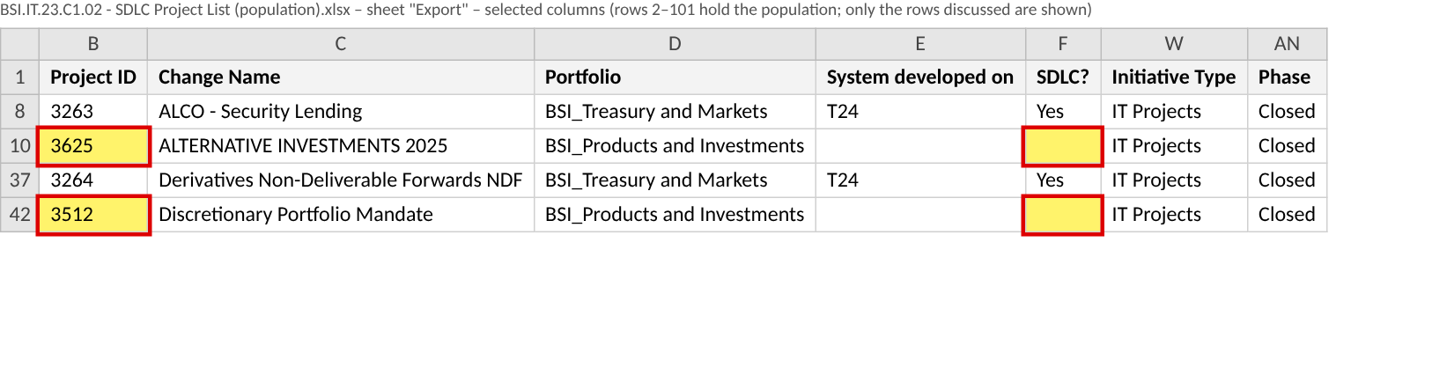
Screenshot 1 – SDLC Project List, sheet "Export": rows 10 (3625) and 42 (3512) have a blank SDLC? flag (file BSI.IT.23.C1.02).
What we need from you
1. The ServiceNow (or Delivery Hub) list of releases deployed to production between 09/01/2025 and 08/31/2026, with a screenshot of the query / filters used.
2. For projects 3625 and 3512: why they were not treated as SDLC projects (for example, configuration only or vendor change), and who decided this.
3. How the "SDLC?" flag is set and reviewed (who updates it and when).
Why it matters: IT RCSA must show the population is complete before relying on the sample. If 3625 or 3512 should have followed the SDLC, they would need to be added to the population and may need testing.

CR-02 – Response page
Completeness of the population could not be confirmed. Please write the explanation below (the box grows as you type).
Response from Joshua de Leon (CR-02)
Explanation:
Evidence provided (file names – please save them in "CR-02 All Population completeness\03 Your Response Evidence"):
Do you agree with the finding? ☐ Agree ☐ Disagree (explain above) Name: ____________________ Date: ___/___/2026
For IT RCSA use – conclusion after the response: ☐ Closed ☐ Still open Comment:

CR-03 – The 2026 SDLC process map is still in Draft
Control: All five controls
Sample: Process documentation
Current result: Observation – OBS-01
Type of request: Validation | Priority: Medium | Affects the rating: No

What we found
- The 2026 SDLC process map (version 2.0) shows CURRENT STATUS "Draft"; DATE APPROVED and APPROVED BY are blank; version 2.0 completion date 05/20/2026 (screenshot 1).
- This means it is not clear which approved procedure was in force during the review period (09/01/2025 – 08/31/2026).
Documents in question
Copies are in the zip folder "CR-03 All Process map in Draft\01 Documents". The package location is shown in brackets.
- BSI.IT.23.C1.01 - 2026 SDLC Process Map.pdf – look at: page 1 – "CURRENT STATUS", "DATE APPROVED", "APPROVED BY", "VERSION HISTORY". (Process map status; package folder: C1 Business Req/CDA/Process Map and Population)
Screenshots (the exact place is marked in red)
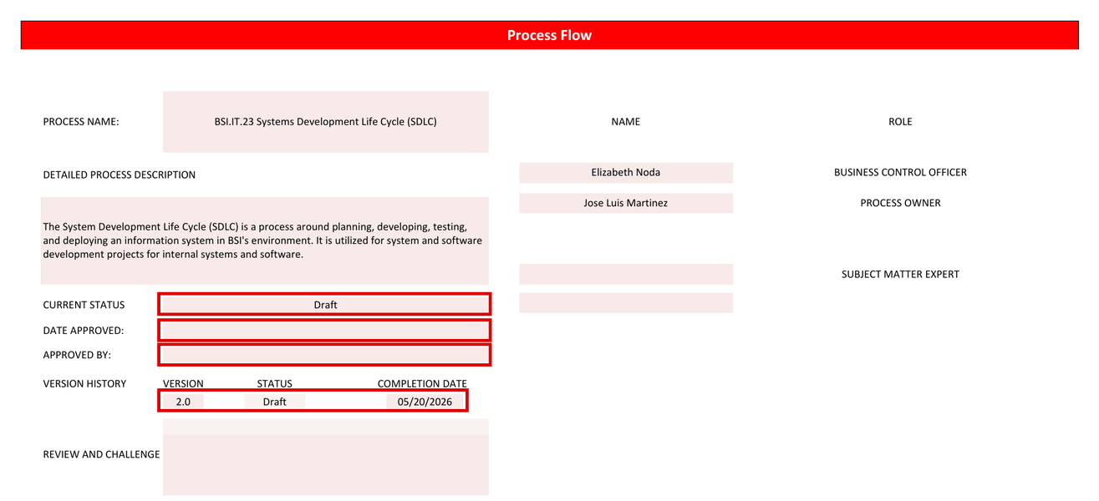
Screenshot 1 – 2026 SDLC process map page 1: status Draft, no approval date or approver (file BSI.IT.23.C1.01).
What we need from you
1. The approved version of the 2026 SDLC process map (with approval date and approver), or
2. confirmation that the 2025 process map remained the approved procedure during the period, and the planned approval date of version 2.0.
Why it matters: The Control Design Assessment relies on an approved process description.

CR-03 – Response page
The 2026 SDLC process map is still in Draft. Please write the explanation below (the box grows as you type).
Response from Joshua de Leon (CR-03)
Explanation:
Evidence provided (file names – please save them in "CR-03 All Process map in Draft\03 Your Response Evidence"):
Do you agree with the finding? ☐ Agree ☐ Disagree (explain above) Name: ____________________ Date: ___/___/2026
For IT RCSA use – conclusion after the response: ☐ Closed ☐ Still open Comment:

CR-04 – Enterprise Architecture approval was requested as a Gate 5 item, after Build started
Control: BSI.IT.23.C13 Design of System and BSI.IT.23.C17 Solution Intent
Sample: Sample 1 – ALCO Security Lending (DH 3263) and Sample 2 – Derivatives NDF (DH 3264)
Current result: Pass with observation – OBS-04
Type of request: Validation | Priority: Medium | Affects the rating: No (today) – would be an exception if ARB review had been required

What we found
- Security Lending: Build gate PTB (4) 10/31/2025 (screenshot 2). EA approval was requested on 12/02/2025 "as part of the artefacts required on Gate 5" and approved 12/04/2025 (screenshot 1).
- NDF Release 01: Build gate PTB (4) 10/31/2025. EA approval was requested on 12/10/2025 as a Gate 5 artifact and approved the same day (screenshot 3).
- The control text does not set the timing, so this is not an exception. But the 2026 control statement requires architecture approval / ARB determination before development starts.
Documents in question
Copies are in the zip folder "CR-04 C13 C17 EA approval after Build\01 Documents". The package location is shown in brackets.
- BSI.IT.23.C13.07 - Security Lending EA approval 12-04-2025.msg – look at: e-mail – "Sent: Tuesday, December 2, 2025"; "Gate 5"; reply "Approved!". (SL EA approval 12/04/2025; package folder: C13 Design of System/CPA/S1 Security Lending)
- BSI.IT.23.C13.05 - Security Lending DRA approval and gate history.docx – look at: screenshot 2 – row "10/31/25 PTB (4) ALL". (SL Build gate; package folder: C13 Design of System/CPA/S1 Security Lending)
- BSI.IT.23.C13.10 - NDF R01 EA approval 12-10-2025.msg – look at: e-mail – "December 10, 2025"; "Gate 5"; reply "Approved!". (NDF R01 EA approval 12/10/2025; package folder: C13 Design of System/CPA/S2 NDF)
- BSI.IT.23.C13.06 - NDF DRA approval and gate history.docx – look at: screenshot 2 – row "10/31/25 PTB (4) R01". (NDF Build gate; package folder: C13 Design of System/CPA/S2 NDF)
Screenshots (the exact place is marked in red)
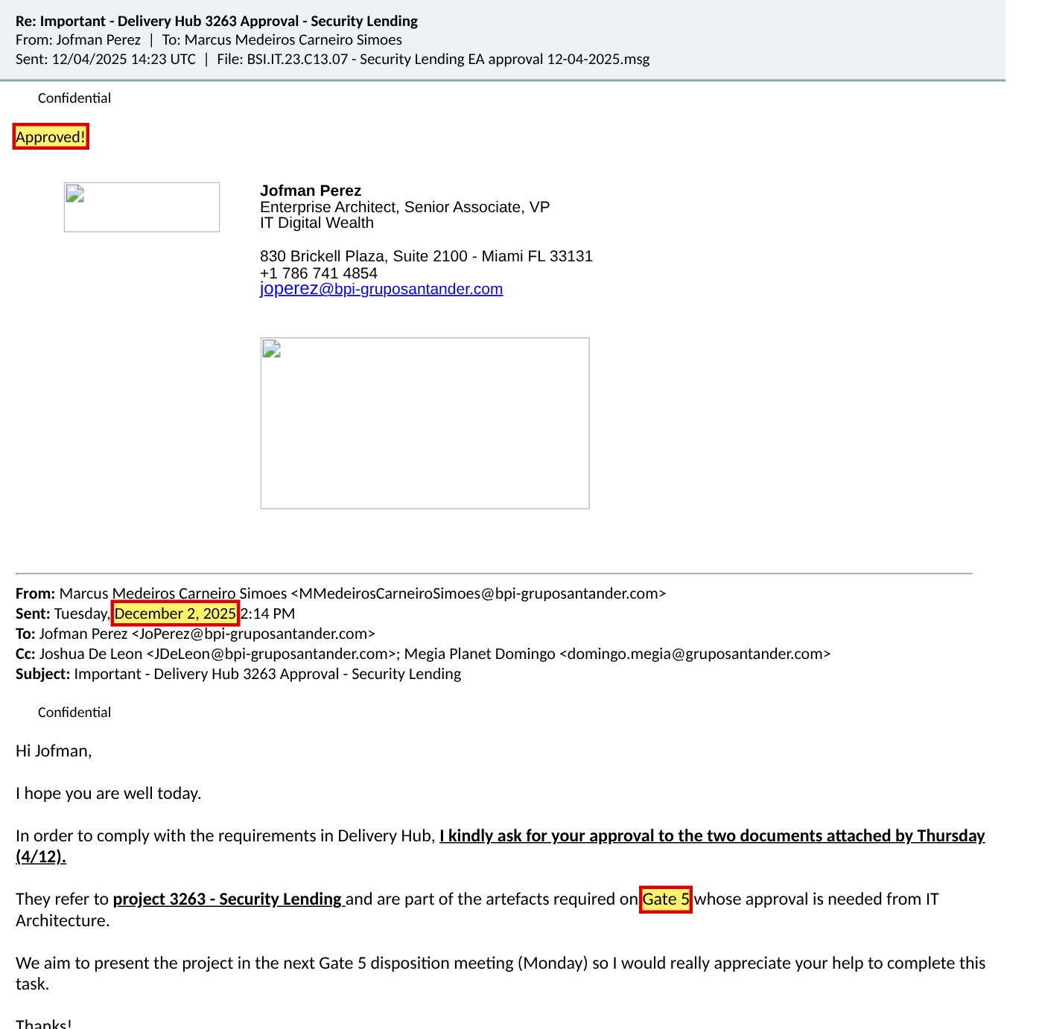
Screenshot 1 – Security Lending EA approval requested 12/02/2025 as a Gate 5 artifact, approved 12/04/2025 (file BSI.IT.23.C13.07).
Screenshot 2 – Security Lending Build gate PTB (4) on 10/31/25 (file BSI.IT.23.C13.05).
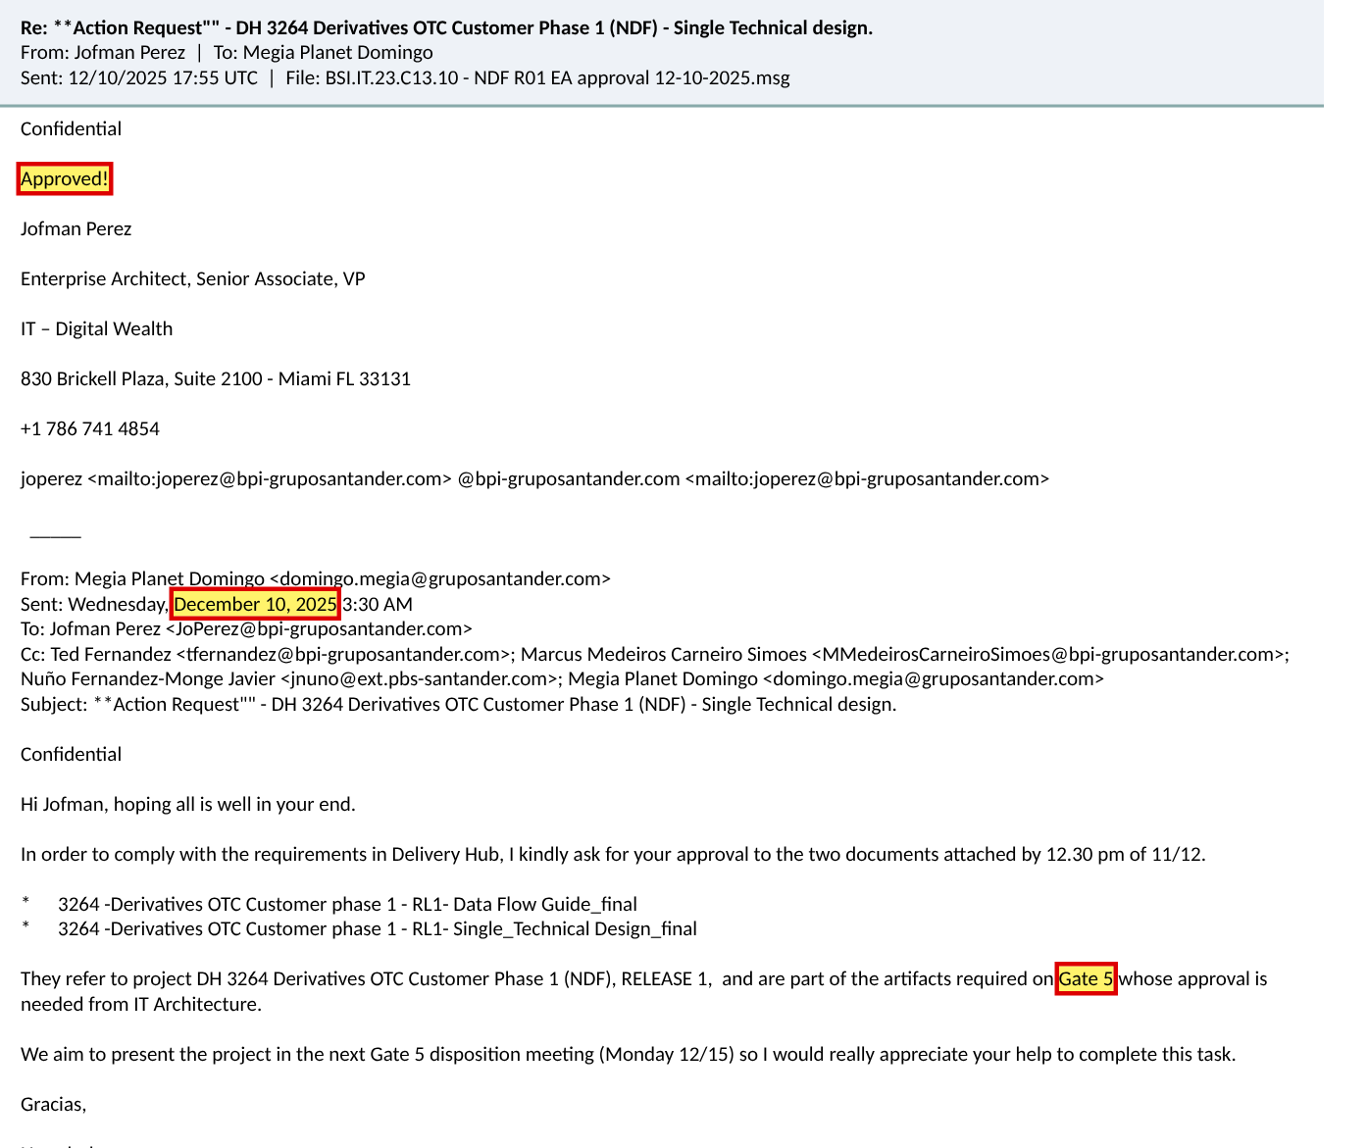
Screenshot 3 – NDF Release 01 EA approval requested and approved 12/10/2025 as a Gate 5 artifact (file BSI.IT.23.C13.10).
What we need from you
1. Was there an earlier Enterprise Architecture review or ARB determination (for example at Gate 3 / ISAR) before 10/31/2025? If yes, please provide it.
2. Confirm at which gate the procedure requires the EA approval and ARB determination, and whether this will move before Build (PTB) in 2026.
Why it matters: If a project needs ARB review, approval after Build has started would be an exception against the control.

CR-04 – Response page
Enterprise Architecture approval was requested as a Gate 5 item, after Build started. Please write the explanation below (the box grows as you type).
Response from Joshua de Leon (CR-04)
Explanation:
Evidence provided (file names – please save them in "CR-04 C13 C17 EA approval after Build\03 Your Response Evidence"):
Do you agree with the finding? ☐ Agree ☐ Disagree (explain above) Name: ____________________ Date: ___/___/2026
For IT RCSA use – conclusion after the response: ☐ Closed ☐ Still open Comment:

CR-05 – HIGH data risk rating – CDO data deliverables not provided
Control: BSI.IT.23.C13 Design of System
Sample: Sample 2 – Derivatives NDF (DH 3264)
Current result: Pass with observation – OBS-05
Type of request: Extra evidence | Priority: Medium | Affects the rating: No

What we found
- The NDF Data Risk Assessment is rated HIGH and shows "CDO: Approved" (screenshot 1).
- Delivery Hub shows the CDO was "In" at the PTP (3) gate with approval date 7/28/2025 (screenshot 2).
- For a HIGH rating the CDO normally requires data deliverables (data model, data lineage / data flow). These were not provided as separate files; IT RCSA relied on the CDO gate approval and the EA-approved "Data Flow Guide".
Documents in question
Copies are in the zip folder "CR-05 C13 NDF CDO data deliverables\01 Documents". The package location is shown in brackets.
- BSI.IT.23.C13.04 - NDF Data Risk Assessment (High).pdf – look at: page 1 – "DRA Rating: HIGH" and "CDO: Approved". (HIGH rating; package folder: C13 Design of System/CPA/S2 NDF)
- BSI.IT.23.C13.06 - NDF DRA approval and gate history.docx – look at: screenshot 2 – Approval Date 7/28/2025; CDO "In". (CDO approval at gate; package folder: C13 Design of System/CPA/S2 NDF)
Screenshots (the exact place is marked in red)
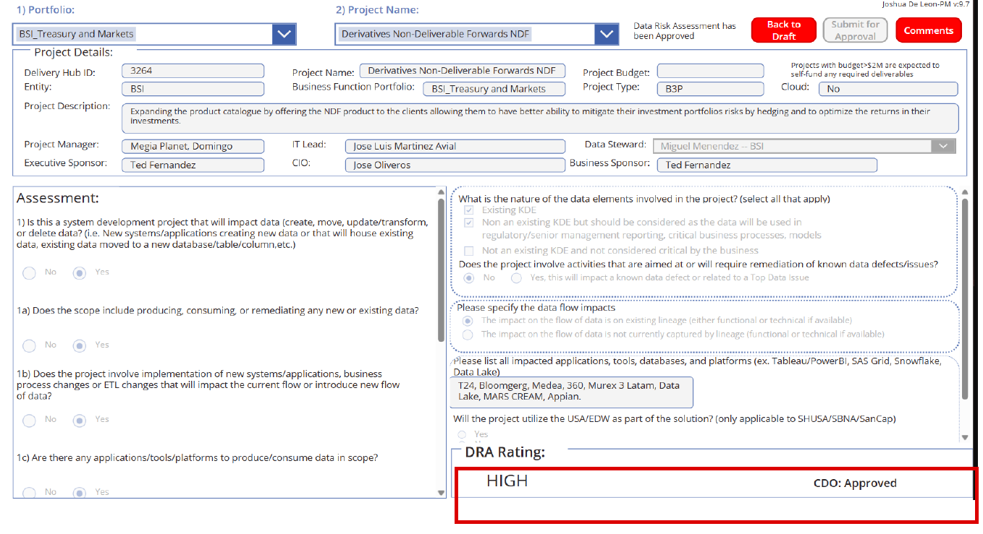
Screenshot 1 – NDF Data Risk Assessment: DRA Rating HIGH, CDO Approved (file BSI.IT.23.C13.04).
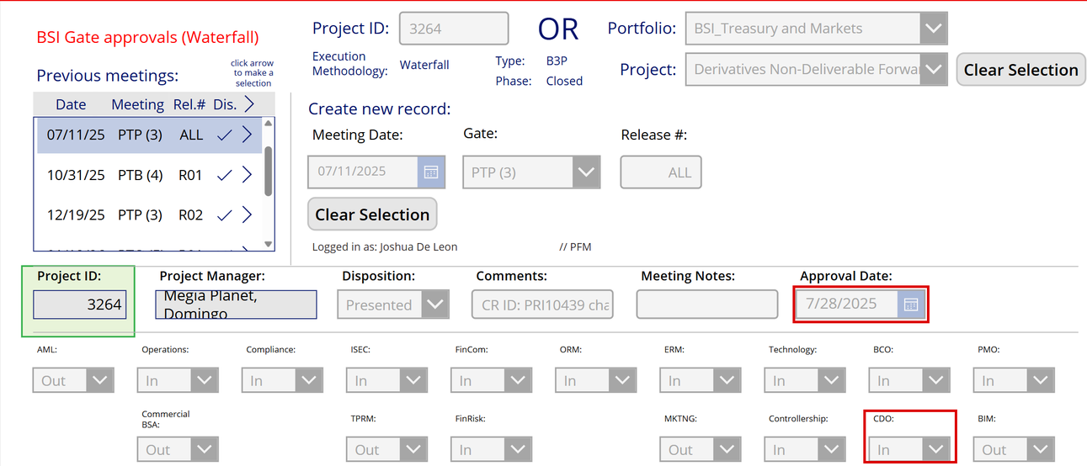
Screenshot 2 – NDF gate PTP (3): approval date 7/28/2025, CDO "In" (file BSI.IT.23.C13.06).
What we need from you
1. The CDO deliverables required for the HIGH rating (data model, data lineage / data flow, or the CDO approval of them), or
2. confirmation from the CDO of what was required for this project and where it is stored.
Why it matters: Confirms the data design review for a HIGH data-risk project was complete.

CR-05 – Response page
HIGH data risk rating – CDO data deliverables not provided. Please write the explanation below (the box grows as you type).
Response from Joshua de Leon (CR-05)
Explanation:
Evidence provided (file names – please save them in "CR-05 C13 NDF CDO data deliverables\03 Your Response Evidence"):
Do you agree with the finding? ☐ Agree ☐ Disagree (explain above) Name: ____________________ Date: ___/___/2026
For IT RCSA use – conclusion after the response: ☐ Closed ☐ Still open Comment:

CR-06 – Security Lending Single Design shows another Delivery Hub ID and has no dates
Control: BSI.IT.23.C17 Solution Intent Document
Sample: Sample 1 – ALCO Security Lending (DH 3263)
Current result: Pass with observation – OBS-08
Type of request: Validation | Priority: Low | Affects the rating: No

What we found
- Slide 5 of the Security Lending Single Design shows Delivery Hub ID/MEGA ID "1886" and project name "Securities Lending (JP Morgan)" instead of DH 3263 (screenshot 1). 1886 appears to be the MEGA ID of the JP Morgan platform.
- The Version Control table on slide 2 has no dates (screenshot 2), and the approval e-mails do not keep the approved attachment, so the exact approved version cannot be matched.
Documents in question
Copies are in the zip folder "CR-06 C17 Single Design wrong project ID\01 Documents". The package location is shown in brackets.
- BSI.IT.23.C17.04 - Security Lending Single Design Feb 2026.pptx – look at: slide 5 "1.1 Introduction & Goals" – "Delivery Hub ID/MEGA ID 1886"; slide 2 "Version Control" (the May 2026 version, BSI.IT.23.C17.07 in the main package folder C17 Solution Intent/CPA/S1 Security Lending, has the same slides). (Design document; package folder: C17 Solution Intent/CPA/S1 Security Lending)
- BSI.IT.23.C17.05 - Security Lending EA approval 12-04-2025.msg – look at: e-mail – only signature images, no attachment. (EA approval; package folder: C17 Solution Intent/CPA/S1 Security Lending)
Screenshots (the exact place is marked in red)
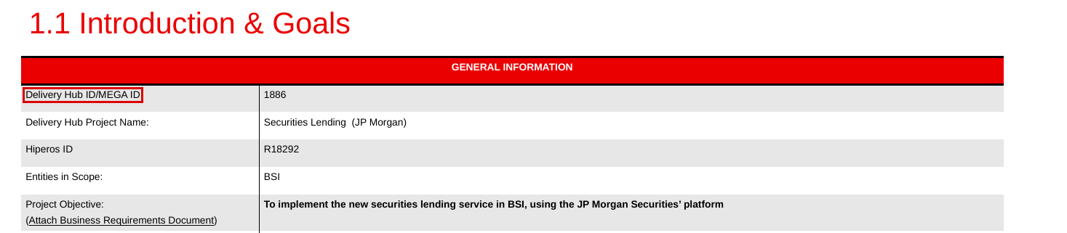
Screenshot 1 – Single Design slide 5: Delivery Hub ID/MEGA ID 1886, "Securities Lending (JP Morgan)" (file BSI.IT.23.C17.04).
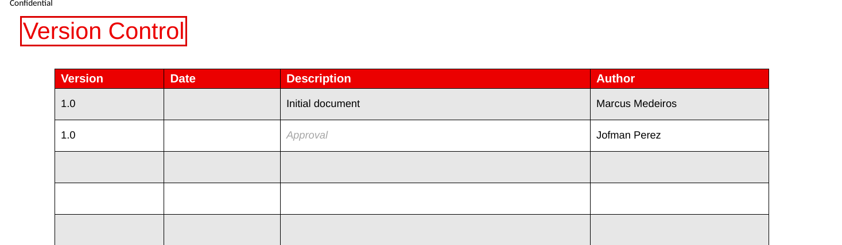
Screenshot 2 – Single Design slide 2: Version Control rows have no dates (file BSI.IT.23.C17.04).
What we need from you
1. Confirm that this Single Design is the document approved for DH 3263 and explain the "1886" reference.
2. If available, the approved version (PDF or the attachment of the approval e-mail) with its date.
Why it matters: Confirms the document approved by Enterprise Architecture is the one for the tested project.

CR-06 – Response page
Security Lending Single Design shows another Delivery Hub ID and has no dates. Please write the explanation below (the box grows as you type).
Response from Joshua de Leon (CR-06)
Explanation:
Evidence provided (file names – please save them in "CR-06 C17 Single Design wrong project ID\03 Your Response Evidence"):
Do you agree with the finding? ☐ Agree ☐ Disagree (explain above) Name: ____________________ Date: ___/___/2026
For IT RCSA use – conclusion after the response: ☐ Closed ☐ Still open Comment:

CR-07 – The final implementation plan was attached after the last approval and earlier versions were deleted
Control: BSI.IT.23.C25 Implement & Deployment
Sample: Sample 1 – ALCO Security Lending (DH 3263) and Sample 2 – Derivatives NDF (DH 3264) – all 4 releases
Current result: Pass with observation – OBS-10
Type of request: Validation | Priority: Medium | Affects the rating: No (today) – would be an exception if the plan changed materially after approval

What we found
- Security Lending R01 (RLSE1271544): approvals 02/24/2026. At that time the ticket held "SLW_Cornercard_Deployment Plan.xlsx" (another project name). It was deleted on 03/11/2026, and the final "3263- Security Lending - Deployment Plan - FINAL" was added 03/11/2026 23:28 and "SLW_SecurityLending_Deployment Plan.xlsx" on 03/12/2026, the day before production (screenshots 1–2).
- Security Lending R02 (RLSE1370716): approval 06/16/2026; the PIP was deleted and re-attached on 06/11/2026 and again on 06/17/2026, the day after the approval (screenshot 3).
- NDF R01 (RLSE1270306): approvals 01/27/2026 00:59; the PIP was deleted and re-attached several times up to 01/28/2026 02:09 (screenshot 4).
- NDF R02 (RLSE1329424): approvals 05/06/2026 07:53; PIP v1.1 and v1.2 deleted, PIP v1.3 attached 05/06/2026 23:55 (screenshot 5).
- Ticket dates are shown in DD/MM/YYYY format in the screenshots.
Documents in question
Copies are in the zip folder "CR-07 C25 Plan versions after approval\01 Documents". The package location is shown in brackets.
- BSI.IT.23.C25.03 - Security Lending R01 ticket RLSE1271544.pdf – look at: pages 3–4 – "Additional comments" / "Work notes" (attachment log). (SL R01 ticket; package folder: C25 Implement Deploy/CPA/S1 Security Lending)
- BSI.IT.23.C25.04 - Security Lending R01 Deployment Plan.xlsx – look at: whole file – final Deployment Plan. (SL R01 plan; package folder: C25 Implement Deploy/CPA/S1 Security Lending)
- BSI.IT.23.C25.06 - Security Lending R02 ticket RLSE1370716.pdf – look at: page 3 – attachment log. (SL R02 ticket; package folder: C25 Implement Deploy/CPA/S1 Security Lending)
- BSI.IT.23.C25.08 - NDF R01 ticket RLSE1270306.pdf – look at: page 5 – attachment log. (NDF R01 ticket; package folder: C25 Implement Deploy/CPA/S2 NDF)
- BSI.IT.23.C25.11 - NDF R02 ticket RLSE1329424.pdf – look at: page 4 – attachment log. (NDF R02 ticket; package folder: C25 Implement Deploy/CPA/S2 NDF)
Screenshots (the exact place is marked in red)
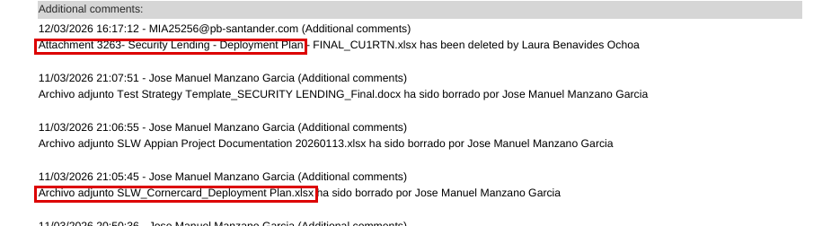
Screenshot 1 – SL R01 ticket page 3: plan deleted; "SLW_Cornercard_Deployment Plan.xlsx" deleted 03/11/2026 (file BSI.IT.23.C25.03).
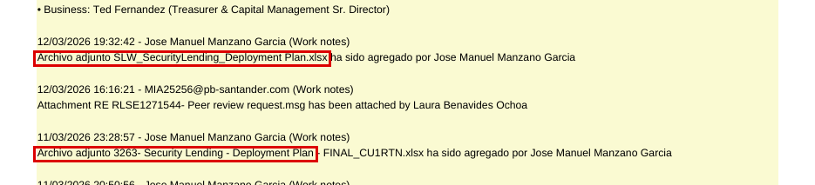
Screenshot 2 – SL R01 ticket page 4: final Deployment Plan added 03/11/2026 and 03/12/2026 (file BSI.IT.23.C25.03).
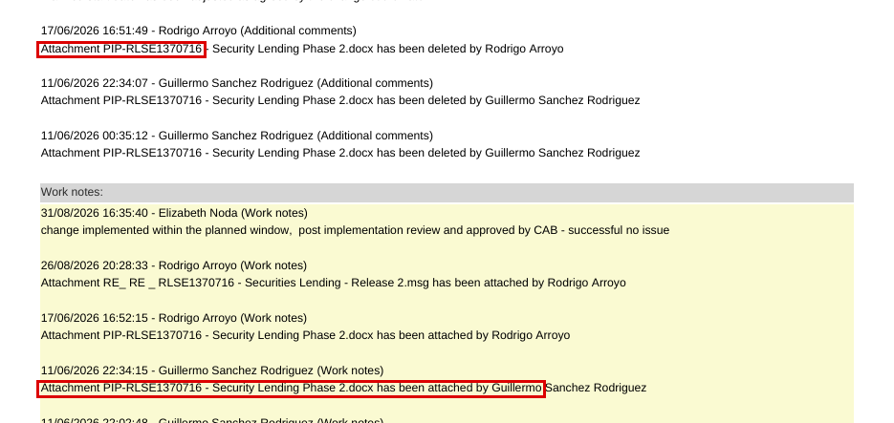
Screenshot 3 – SL R02 ticket page 3: PIP deleted and re-attached (file BSI.IT.23.C25.06).
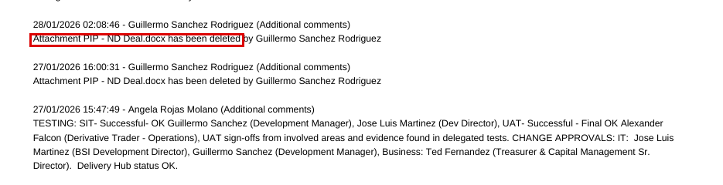
Screenshot 4 – NDF R01 ticket page 5: PIP deleted after approvals (file BSI.IT.23.C25.08).
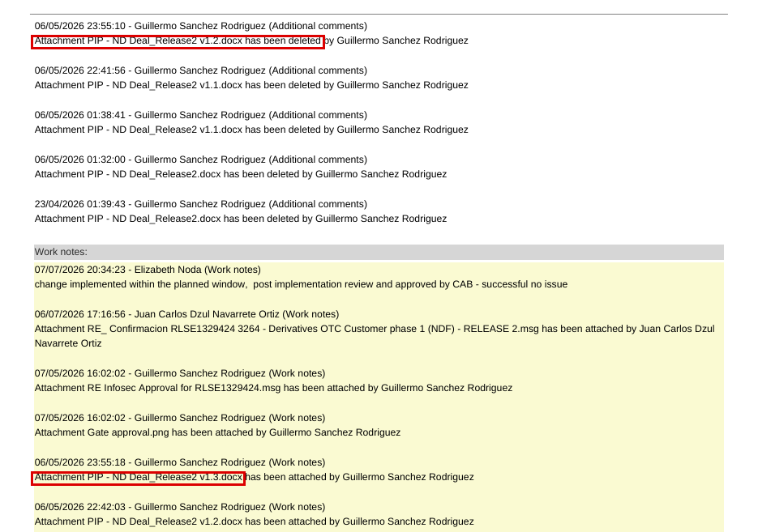
Screenshot 5 – NDF R02 ticket page 4: PIP v1.1/v1.2 deleted, v1.3 attached after approval (file BSI.IT.23.C25.11).
What we need from you
1. For each of the 4 releases: confirm what changed between the version approved and the final version (or provide the version that was approved), and confirm the changes were not significant.
2. Explain why the Security Lending R01 ticket held a "Cornercard" deployment plan at approval time.
3. Confirm whether Change Management requires re-approval when the implementation plan changes after approval.
Why it matters: The control requires the approved plan to be the one deployed. If a significant change was made after approval without re-approval, it would be an exception.

CR-07 – Response page
The final implementation plan was attached after the last approval and earlier versions were deleted. Please write the explanation below (the box grows as you type).
Response from Joshua de Leon (CR-07)
Explanation:
Evidence provided (file names – please save them in "CR-07 C25 Plan versions after approval\03 Your Response Evidence"):
Do you agree with the finding? ☐ Agree ☐ Disagree (explain above) Name: ____________________ Date: ___/___/2026
For IT RCSA use – conclusion after the response: ☐ Closed ☐ Still open Comment:

CR-08 – Roll Back section of the Security Lending R01 Deployment Plan is empty
Control: BSI.IT.23.C25 Implement & Deployment
Sample: Sample 1 – ALCO Security Lending (DH 3263), Release 01
Current result: Pass with observation – OBS-03
Type of request: Validation | Priority: Low | Affects the rating: No

What we found
- The "Roll Back" rows of the Deployment Plan (sheet "Deployment Plan RLSE ID") are empty (screenshot 1).
- The rollback is written in the release ticket ("Restore old packages…"; backout "Delete DB tables and remove new apps"), so IT RCSA accepted it.
Documents in question
Copies are in the zip folder "CR-08 C25 Rollback rows empty\01 Documents". The package location is shown in brackets.
- BSI.IT.23.C25.04 - Security Lending R01 Deployment Plan.xlsx – look at: sheet "Deployment Plan RLSE ID" – "Roll Back" section (rows under the yellow bar). (Empty rollback; package folder: C25 Implement Deploy/CPA/S1 Security Lending)
- BSI.IT.23.C25.03 - Security Lending R01 ticket RLSE1271544.pdf – look at: page 2 – Implementation plan / Backout plan. (Rollback in ticket; package folder: C25 Implement Deploy/CPA/S1 Security Lending)
Screenshots (the exact place is marked in red)
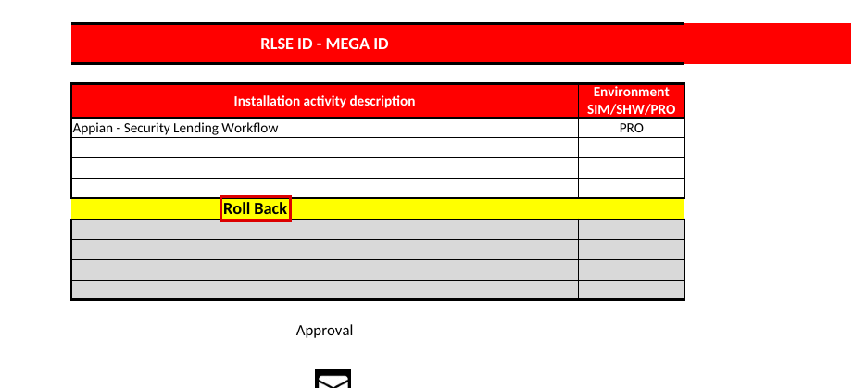
Screenshot 1 – Deployment Plan: Roll Back rows empty (file BSI.IT.23.C25.04).
What we need from you
1. Confirm that the rollback in the ServiceNow ticket is the approved rollback plan for this release.
Why it matters: Confirms a rollback plan existed and was approved.

CR-08 – Response page
Roll Back section of the Security Lending R01 Deployment Plan is empty. Please write the explanation below (the box grows as you type).
Response from Joshua de Leon (CR-08)
Explanation:
Evidence provided (file names – please save them in "CR-08 C25 Rollback rows empty\03 Your Response Evidence"):
Do you agree with the finding? ☐ Agree ☐ Disagree (explain above) Name: ____________________ Date: ___/___/2026
For IT RCSA use – conclusion after the response: ☐ Closed ☐ Still open Comment:

CR-09 – The same login (MIASANG) is used on production and non-production
Control: BSI.IT.23.C4 Segregated Environments
Sample: Sample 1 – ALCO Security Lending (DH 3263) and Sample 2 – Derivatives NDF (DH 3264)
Current result: Pass with observation – OBS-12
Type of request: Validation + extra evidence | Priority: Medium | Affects the rating: No (today) – would be an exception if developers can change production

What we found
- Screenshot 2 (production, server miasx1) and screenshot 6 (non-production, server miasx4) in the Segregated Environments document both use login "MIASANG" (screenshot 1).
Documents in question
Copies are in the zip folder "CR-09 C4 Same login prod and non-prod\01 Documents". The package location is shown in brackets.
- BSI.IT.23.C4.03 - Security Lending Segregated Environments.docx – look at: screenshots 2 and 6 – "Server Login" windows. (Same login; package folder: C4 Segregated Env/CPA/S1 Security Lending)
- BSI.IT.23.C4.08 - NDF Segregated Environments.docx – look at: same document for NDF. (Same login; package folder: C4 Segregated Env/CPA/S2 NDF)
Screenshots (the exact place is marked in red)
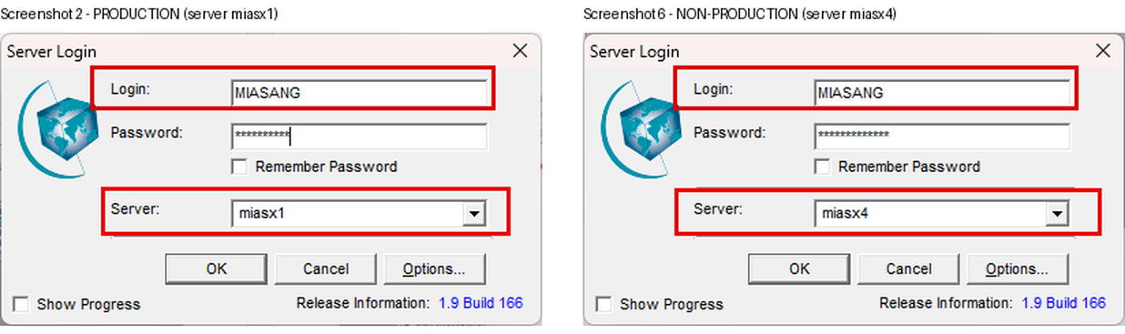
Screenshot 1 – T24 login MIASANG on production (miasx1) and non-production (miasx4) (file BSI.IT.23.C4.03, screenshots 2 and 6).
What we need from you
1. Who owns the MIASANG account and what is its role (developer, support, administrator)?
2. Evidence of its access rights in production (for example a T24 user profile / SMS screen) showing it cannot change production code or data, or the approval for that access.
3. Confirm whether developers have any access to production.
Why it matters: Segregation means developers should not be able to change production. A shared login could break this.

CR-09 – Response page
The same login (MIASANG) is used on production and non-production. Please write the explanation below (the box grows as you type).
Response from Joshua de Leon (CR-09)
Explanation:
Evidence provided (file names – please save them in "CR-09 C4 Same login prod and non-prod\03 Your Response Evidence"):
Do you agree with the finding? ☐ Agree ☐ Disagree (explain above) Name: ____________________ Date: ___/___/2026
For IT RCSA use – conclusion after the response: ☐ Closed ☐ Still open Comment:

CR-10 – Non-production environment holds client deals (possible copy of production data)
Control: BSI.IT.23.C4 Segregated Environments
Sample: Sample 1 – ALCO Security Lending (DH 3263) and Sample 2 – Derivatives NDF (DH 3264)
Current result: Pass with observation – OBS-13
Type of request: Validation + extra evidence | Priority: Medium | Affects the rating: No (control text does not cover data masking)

What we found
- The non-production environment MIAAFT28 is labelled "SANTANDER OCT 2025 EOM" and lists ND deals with counterparties and deal dates from November 2025 (screenshot 1).
- This suggests a copy of production month-end data in a test environment.
Documents in question
Copies are in the zip folder "CR-10 C4 Client data in non-prod\01 Documents". The package location is shown in brackets.
- BSI.IT.23.C4.03 - Security Lending Segregated Environments.docx – look at: screenshot 8 – T24 Desktop title "MIAAFT28 ON MIASX4 - SANTANDER OCT 2025 EOM"; columns COUNTERPARTY and DEAL.DATE. (Client deals in non-prod; package folder: C4 Segregated Env/CPA/S1 Security Lending)
Screenshots (the exact place is marked in red)
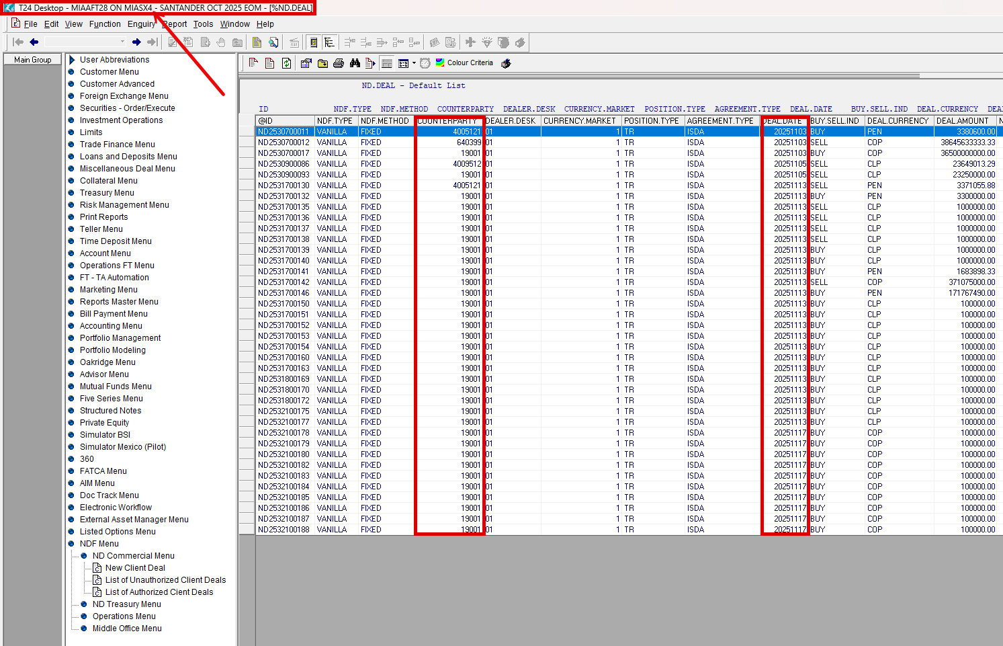
Screenshot 1 – Non-production T24 MIAAFT28 "SANTANDER OCT 2025 EOM" with client deals (file BSI.IT.23.C4.03, screenshot 8).
What we need from you
1. Confirm whether MIAAFT28 is a copy of production data.
2. If yes: evidence that client data is masked, or the Information Security approval to use production data in non-production, and who can access MIAAFT28.
Why it matters: Production client data in test environments can be disclosed to people who should not see it (risk BSI.IT.23.R3).

CR-10 – Response page
Non-production environment holds client deals (possible copy of production data). Please write the explanation below (the box grows as you type).
Response from Joshua de Leon (CR-10)
Explanation:
Evidence provided (file names – please save them in "CR-10 C4 Client data in non-prod\03 Your Response Evidence"):
Do you agree with the finding? ☐ Agree ☐ Disagree (explain above) Name: ____________________ Date: ___/___/2026
For IT RCSA use – conclusion after the response: ☐ Closed ☐ Still open Comment:

CR-11 – No register of exceptions (development or testing in production) was provided
Control: BSI.IT.23.C4 Segregated Environments
Sample: Control level
Current result: Pass with observation – OBS-14
Type of request: Extra evidence | Priority: Medium | Affects the rating: No

What we found
- The control allows development or testing in production only as an exception approved by Information Security.
- No register of such exceptions, and no confirmation that there were none, was provided for 09/01/2025 – 08/31/2026. There is no document to screenshot – this item is the missing evidence.
Documents in question
Copies are in the zip folder "CR-11 C4 No exception register\01 Documents". The package location is shown in brackets.
- BSI.IT.23.C4.01 - 2026 SDLC Process Map.pdf – look at: process map – BSI.IT.23.C4 step. (Control description; package folder: C4 Segregated Env/CDA/Process Map and Population)
Screenshots: none – no document was provided for this point (this is the missing evidence).
What we need from you
1. The list (register) of exceptions where development or testing was done in production during 09/01/2025 – 08/31/2026, with the Information Security (CISO) approvals, or
2. a signed confirmation from Information Security / IT that there were no such exceptions in the period.
Why it matters: Shows the exception part of the control operated.

CR-11 – Response page
No register of exceptions (development or testing in production) was provided. Please write the explanation below (the box grows as you type).
Response from Joshua de Leon (CR-11)
Explanation:
Evidence provided (file names – please save them in "CR-11 C4 No exception register\03 Your Response Evidence"):
Do you agree with the finding? ☐ Agree ☐ Disagree (explain above) Name: ____________________ Date: ___/___/2026
For IT RCSA use – conclusion after the response: ☐ Closed ☐ Still open Comment:

CR-12 – Segregated Environments evidence was created after the review period and screenshots have no date
Control: BSI.IT.23.C4 Segregated Environments
Sample: Sample 1 – ALCO Security Lending (DH 3263) and Sample 2 – Derivatives NDF (DH 3264)
Current result: Pass with observation – OBS-15
Type of request: Validation + extra evidence | Priority: Low | Affects the rating: No

What we found
- The Word file was created on 10/22/2026 by Guillermo Sanchez (Miami) – after the period ended on 08/31/2026 (screenshot 1).
- The screenshots have no capture date. IT RCSA used the deal dates visible on screen (production deals 03/26/2026 and 07/23/2026 – screenshot 2) to place them in the period.
Documents in question
Copies are in the zip folder "CR-12 C4 Evidence created after period\01 Documents". The package location is shown in brackets.
- BSI.IT.23.C4.03 - Security Lending Segregated Environments.docx – look at: File > Info (properties): Created 10/22/2026; screenshots 1–8. (Evidence date; package folder: C4 Segregated Env/CPA/S1 Security Lending)
- BSI.IT.23.C4.08 - NDF Segregated Environments.docx – look at: same document for NDF. (Evidence date; package folder: C4 Segregated Env/CPA/S2 NDF)
Screenshots (the exact place is marked in red)
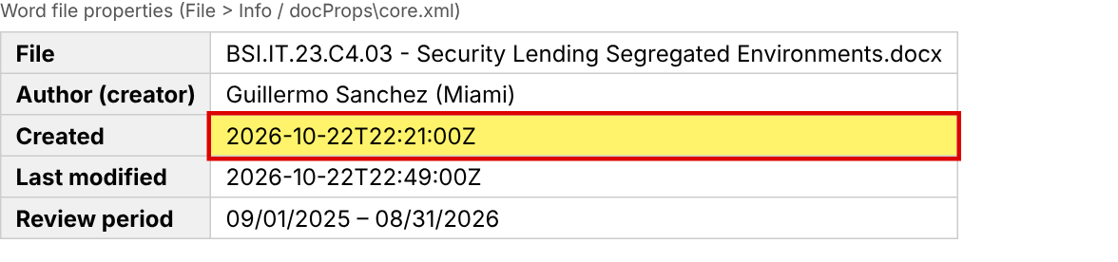
Screenshot 1 – File properties of the Segregated Environments document: created 10/22/2026 (file BSI.IT.23.C4.03).
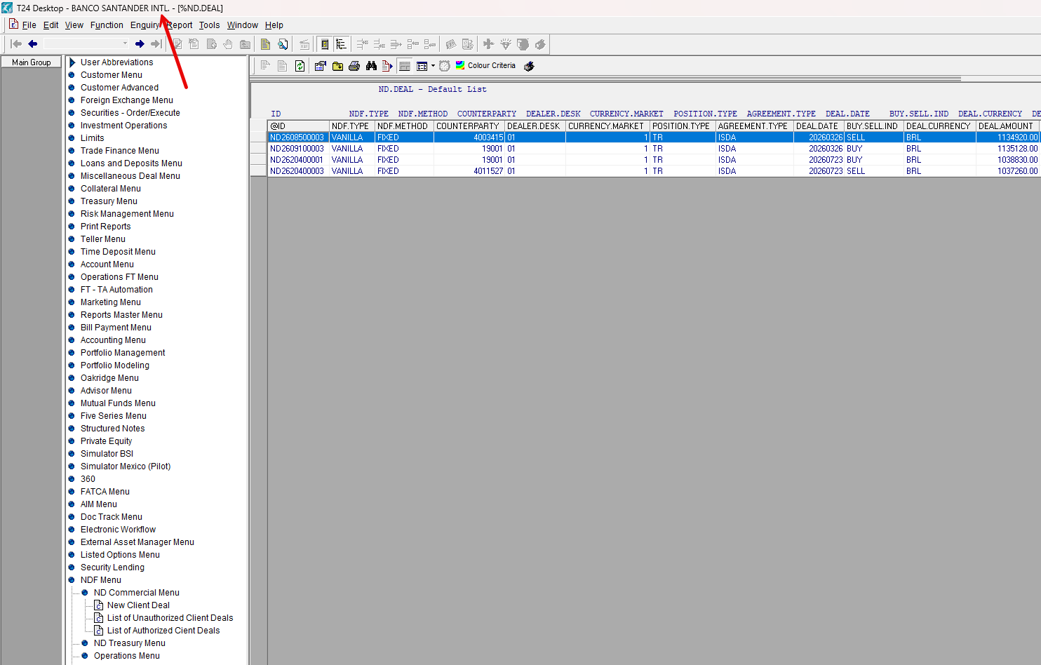
Screenshot 2 – Production T24 deals list (screenshot 4 of the document): no capture date; deal dates 2026-03-26 and 2026-07-23 (file BSI.IT.23.C4.03).
What we need from you
1. Confirm the environments (servers miasx1 / miasx4, MIAPRD / MIAAFT28) were the same during 09/01/2025 – 08/31/2026, and
2. if available, dated evidence from the period (for example server inventory / CMDB extract or environment configuration with dates).
Why it matters: Evidence should show the control operated during the review period.

CR-12 – Response page
Segregated Environments evidence was created after the review period and screenshots have no date. Please write the explanation below (the box grows as you type).
Response from Joshua de Leon (CR-12)
Explanation:
Evidence provided (file names – please save them in "CR-12 C4 Evidence created after period\03 Your Response Evidence"):
Do you agree with the finding? ☐ Agree ☐ Disagree (explain above) Name: ____________________ Date: ___/___/2026
For IT RCSA use – conclusion after the response: ☐ Closed ☐ Still open Comment:

CR-13 – No evidence of separate Appian development, test and production environments
Control: BSI.IT.23.C4 Segregated Environments
Sample: Sample 1 – ALCO Security Lending (DH 3263), Release 01 (Appian)
Current result: Pass with observation – OBS-16
Type of request: Extra evidence | Priority: Medium | Affects the rating: No

What we found
- Security Lending Release 01 was built on Appian. The Segregated Environments document only shows T24.
- IT RCSA relied on the ticket: test plan "DEV test - unit test and UAT by final users" and delegated tests "IT certification – OK" 01/14/2026 and "UAT – OK" 01/22/2026, before production on 03/13/2026 (screenshots 1–2).
Documents in question
Copies are in the zip folder "CR-13 C4 Appian environments\01 Documents". The package location is shown in brackets.
- BSI.IT.23.C4.06 - Security Lending R01 ticket RLSE1271544.pdf – look at: page 2 – "Test plan"; page 9 – "Delegated tests". (Appian testing; package folder: C4 Segregated Env/CPA/S1 Security Lending)
- BSI.IT.23.C4.03 - Security Lending Segregated Environments.docx – look at: whole document – T24 only. (No Appian screens; package folder: C4 Segregated Env/CPA/S1 Security Lending)
Screenshots (the exact place is marked in red)
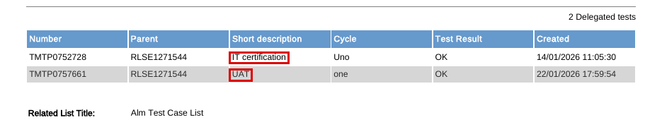
Screenshot 1 – SL R01 ticket page 9: IT certification OK 01/14/2026, UAT OK 01/22/2026 (file BSI.IT.23.C4.06).
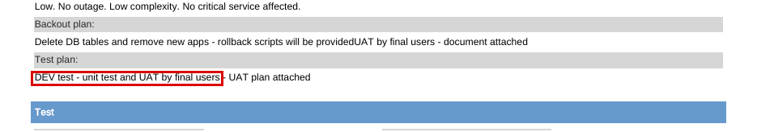
Screenshot 2 – SL R01 ticket page 2: test plan "DEV test - unit test and UAT by final users" (file BSI.IT.23.C4.06).
What we need from you
1. Screenshots (or an environment list) showing the separate Appian DEV, TEST and PROD environments used for Security Lending (URL / server and environment name).
2. Who can deploy to Appian production (deployment role) – to confirm developers cannot.
Why it matters: Completes the segregation evidence for the Appian platform.

CR-13 – Response page
No evidence of separate Appian development, test and production environments. Please write the explanation below (the box grows as you type).
Response from Joshua de Leon (CR-13)
Explanation:
Evidence provided (file names – please save them in "CR-13 C4 Appian environments\03 Your Response Evidence"):
Do you agree with the finding? ☐ Agree ☐ Disagree (explain above) Name: ____________________ Date: ___/___/2026
For IT RCSA use – conclusion after the response: ☐ Closed ☐ Still open Comment:

For information only – no response needed
These are recommendations on documentation or the wording of the control. They do not affect the test results.
- OBS-02 (C1): Security Lending BRDs complete only the Security non-functional section; R02 BRD revision history stops at v0.2.
- OBS-06 (C1): Control statement does not say who performs the control, what evidence is kept, or how requirement changes after PTB are approved.
- OBS-07 (C17): C17 is in the 2025 process map but not in the 2026 process map, although it is still a Key Control.
- OBS-09 (C4): Heracles frequency is "Annual" but the activity happens for every release.

Results that do not need anything from you
- C13 Design of System – both samples Pass (CR-04 and CR-05 are confirmations only).
- C17 Solution Intent – both samples Pass (CR-04 and CR-06 are confirmations only).
- C25 Implement & Deployment – both samples Pass (CR-07 and CR-08 are confirmations only).
- C4 Segregated Environments – both samples Pass (CR-09 to CR-13 are confirmations / extra evidence).
- C1 Business Requirement – Sample 2 (NDF) Pass; Sample 1 (Security Lending) Fail – see CR-01.

